Keywords

Wave overtopping, wave runup, overtopping, runup, WTI 2017, safety assessment, software, failure mechanism.

Summary

This document contains the requirements and functional design for a software kernel that computes the wave overtopping at dikes. This kernel will be referred to as the 'overtopping' kernel. This kernel eventually forms a part of the WTI 2017 failure mechanism library.

References

KPP 2015 WK07 Waterveiligheidsinstrumentarium - VTV Tools.

|  |  |  |  |  |  |  |  |
| --- | --- | --- | --- | --- | --- | --- | --- |
| Version | Date | Author | Initials | Review | Initials | Approval | Initials |
| 1.0 | 2012 | B. Kuijper  M.T. Duits  R.G. Kamp |  | J.P. de Waal |  |  |  |
| 2.0 | aug. 2015 | J.P. de Waal |  | P. van Steeg |  | M. van Gent |  |
|  |  |  |  |  |  |  |  |

|  |
| --- |
| State  draft  This is a draft report, intended for discussion purposes only. No part of this report may be relied upon by either principals or third parties. |

Contents

1 Introduction 1

1.1 About this document 1

1.1.1 Purpose and scope of this document 1

1.1.2 The author(s) 1

1.1.3 Formula notation 2

1.2 Other system documents 2

1.3 Assumptions and constraints 2

2 Requirements 5

2.1 Assumptions and constraints 5

3 General program structure 7

3.1 Input data 7

3.2 Output data 7

3.3 Program steps 7

4 Input parameters and cross section 9

4.1 Introduction 9

4.2 Load parameters: input and validation 9

4.3 Model factors: input and validation 9

4.4 Cross section data: input and validation 10

4.5 Load parameters: adjustments and derivatives 11

4.5.1 Adjustment to the water level in case of overflow 11

4.5.2 Adjustment to the wave conditions in case of shallow water 11

4.5.3 Calculate the wave length 11

4.5.4 Calculate the wave steepness 11

4.6 Cross section manipulations 12

4.6.1 Force a specified crest level 12

4.6.2 Merge two sequential berms 12

4.6.3 Split cross section for at least one wide berm 13

4.6.4 Force horizontal berms 14

4.6.5 Remove a horizontal berm 16

4.7 Calculate influence factors angle of wave attack 16

4.8 Combine computation results for cross sections 17

4.9 Calculate limit state function wave overtopping discharge 18

5 Computation method 19

5.1 Introduction 19

5.2 Calculation steps 19

5.3 Detailed functions 19

5.3.1 Calculate representative slope angle 19

5.3.2 Calculate 2% wave run-up 20

5.3.3 Calculate intersection point breaking and non-breaking waves 21

5.3.4 Calculate influence factor roughness on slope 22

5.3.5 Calculate influence factor berms 23

5.3.6 Calculate influence factor one berm 24

5.3.7 Combine influence factors berms 26

5.3.8 Calculate adjustment of influence factors 27

5.3.9 Calculate wave overtopping discharge 29

6 Foreshore 31

7 Notes 33

8 References 35

# Introduction

## About this document

### Purpose and scope of this document

This document contains the requirements and functional design for a software kernel that computes the wave overtopping at dikes. This kernel will be referred to as the 'overtopping' kernel. This kernel eventually forms a part of the WTI 2017 failure mechanism library.

Like all other failure mechanism modules, this module has two objectives:

* to be called in a deterministic environment, from a stand alone application such as RingToets
* to be called in a probabilistic environment such as Hydra-Ring.

The primary output of the overtopping module consists of:

* the 2% wave run-up
* the wave overtopping discharge
* the value of the limit state function (z-function) for the wave overtopping discharge.

The computation of overflow is not included in this module: the z-function (as part of the output) explicitly pertains to the wave overtopping discharge only, i.e. for water levels that do not exceed the crest level. From tests with Hydra-Ring as a probabilistic environment, it was concluded that it is better to combine separate z-functions for wave overtopping and overflow within the probabilistic environment than to try and define a single z-function for both wave overtopping and overflow as a part of the failure mechanism module.

The document will not give any background on the context of the WTI project and on the derivation or motivation of the supported physical models. This Functional Design is based on two documents: [TAW, 2002] and [TDR, 2005]. The assumption is made that the contents of these two documents is correct. All relevant elements of these two documents for the overtopping module are described in the next chapters.

Chapter 2 discusses the requirements. Chapter 3 gives the general program structure. Chapter 4 describes the input parameters and the cross section. Chapter 5 describes the computation method to calculate the wave run-up and wave overtopping discharge over the crest of a dike. Chapter 6 gives the computation method in case of berms which are that wide that they must be treated as foreshores (in a simplified way). Finally, in Chapter 7 some notes on the present computation method are given.

### The author(s)

Originally this document was written by B. Kuijper, M.T. Duits and R.G. Kamp, all from HKV consultants. Later the kernel structure was adjusted in order to better fit into the probabilistic program Hydra-Ring. Moreover, a Deltares template for this type of documents evolved. The document was then adapted according to these developments by J.P. de Waal from Deltares.

### Formula notation

In some cases this document presents a formula that represents a (software) assignment, rather than an equation. In order to distinguish between these two types of formulae a different notation is used:

* "=" refers to an equation
* ":=" refers to an assignment

## Other system documents

The full documentation on the grass runup kernel comprises the following documents.

|  |  |
| --- | --- |
| **Title** | **Content** |
| [Scientific background]  [TAW, 2002] and [TDR, 2005] | Scientific background of methods and rules |
| Requirements and functional design | This document |
| Technical Design | Definition of the different software components and their interaction |
| Programmers documentation | Description of the arguments and usage of different software components, generated from in-line comment with Doxygen |
| Test plan | Description of the different regression and acceptation tests, including target values. |
| Test report | Description of the test results. |

## Assumptions and constraints

1. As a general constraint, the development process needs to comply with the general process description for WTI software, contained in a separate document (Kuyper, 2012).
2. As a general constraint, the kernel needs to comply with the relevant general requirements and further design rules for the programming, documentation and testing of WTI software. This set of requirements and rules is contained in a separate document (Brinkman, 2012). The set includes some of the constraints listed hereafter.
3. As a general WTI software constraint, the failure mechanism library will contain only components for a deterministic analysis to calculate a factor of safety or a limit state function (LSF, for probabilistic analysis), with a choice between different models for different (sub)mechanisms, that can be called separately. In case of different submechanisms, the limit state functions will be supplied only per submechanism. The combination of these submechanisms inside a certain probabilistic procedure is expected to be performed in the external software (notably the probabilistic core of Ringtoets, called Hydra-Ring).
4. As a general WTI software constraint, all model constants need to be adaptable outside the kernel, in order to allow for varying values during probabilistic analysis.
5. As a general WTI software constraint, the failure mechanism library needs to support at least all models that are prescribed for detailed assessment according to the VTV2017.

As a general WTI software constraint, the software interface (API) must allow usage from C# (Ringtoets), as well as from FORTRAN (Hydra-Ring), and MATLAB (test environment). The API should include a pointer to a feedback function for messages and warnings, with standardized interface.

# Requirements

## Assumptions and constraints

This chapter describes the requirements for the overtopping module.

FR1 The overtopping module can be called from a stand alone application such as Ringtoets.

FR2 The overtopping module can be called from a probabilistic environment such as Hydra-Ring.

FR3 The output of the FTO overtopping module is the 2% wave run-up, the overtopping discharge and the value for the limit state function for the wave overtopping discharge.

FR4 The hydraulic load level as function of a critical wave the overtopping discharge will not be included.

FR5 The check on good schematisation practice of the geometry needs to take place in the calling environment; it will not be performed in the overtopping module.

FR6 Horizontal berm sections are allowed.

FR7 Two sequential berms are allowed.

FR8 Other boundary conditions for the dike profile stem from the ‘Hydra’s’ and are given in section 4.2.

FR9 The effect of vertical walls will not be included.

FR10 A computation for oblique, long crested waves will not be included.

FR11 Six model parameters will be programmed as input parameters for the overtopping module.

FR12 The point of transition from breaking waves to non-breaking waves will be computed and not selected as a constant value of 1.8.

FR13 The computation should not exit with an error code. An error code is allowed in case of a physically impossible answer.

# General program structure

This chapter describes the input/output of the program and the program structure in general. More details (especially for the input data requirements and the calculation procedure) are given in the following chapters.

## Input data

The input for the overtopping module consists of:

* Load parameters
* Cross section data
* Model factors

The load parameters are the still water level and the wave parameters at the toe of the dike. Any reduction of the wave parameters due to the presence of a foreland has to take place before the wave parameters are given as input to the overtopping module. In other words: the calculation of the wave reduction through a foreland is not part of this program.

Since no foreland is used within the overtopping module, the cross section consists only of dike segments from the toe of the dike to the outer crest level. These segments are given by the (x,y) coordinates and have to satisfy certain boundary conditions (section 4.4). The roughness reduction factors for the different dike segments are also part of the input data, as is the outer normal (the orientation) of the dike, which is necessary to determine the angle of wave attack.

Finally some model factors (used in the calculation of the wave run-up and overtopping) are part of the input data of the module. See section 4.3 for more details.

## Output data

The output of the overtopping module consists of:

* Main results
* Error information
* Version information

The main results are the 2% wave run-up (in m), the wave overtopping discharge (in m3 per m per s) and the value for the limit state function for the wave overtopping discharge. The error information consists of a code (flag for success) and an error message (for failure).

## Program steps

The general program structure of the overtopping module consists of the following steps:

1. Check input:
   1. Load parameters [section 4.2].
   2. Model factors [section 4.3].
   3. Check input: cross section data [section 4.4].
2. If applicable, adjust the geometry so that the crest level of the geometry equals the input value for the crest level (which is given separately from the input geometry) [section 4.6.1].
3. If applicable, merge two sequential berms [section 4.6.2].
4. Calculate the influence factors angle of wave attack [section 4.6.3]
5. If applicable, adjust the wave parameters to account for very oblique wave attack [section 4.7].
6. If applicable, adjust the water level [section 4.5.1].
7. If applicable, adjust the wave parameters to account for shallow water [section 4.5.2].
8. If there is no wave attack (wave height zero or wave period zero)

then assign zero to 2% wave run-up (z2%) and wave overtopping discharge (q0)

go to step 12

else proceed with step 9

1. If the geometry contains at least one 'wide berm' then generate two adjusted geometries, both without any 'wide berm' [section 4.6.3].
2. For each geometry:

If the cross section does not contain a foreshore

then calculate 2% wave run-up (z2%) and wave overtopping discharge (q0) [chapter 5]

else calculate 2% wave run-up (z2%) and wave overtopping discharge (q0), taking foreshores into account [chapter 6]

1. If applicable, combine results for wave run-up (z2%) and overtopping discharge (q0) for all geometries [section 4.8].
2. Compute the value for the limit state function for the wave overtopping discharge [section 4.9].

# Input parameters and cross section

## Introduction

This chapter describes the input parameters for the overtopping module, including the cross section of the dike. The boundary conditions for these data are given, and also a description of the procedure to check the input data for the cross section. Finally, a procedure is given to make necessary adjustments to the cross section as a pre-processing step before the actual calculation of the wave run-up and overtopping.

## Load parameters: input and validation

The following model factors are required as input:

h (m+NAP) Still water level (i.e. local water level)

Hm0 (m) Significant wave height

Tm-1,0 (s) Spectral wave period

ϕ (°N) Wave direction

The module performs the following checks on the input data mentioned above:

* Significant wave height: Hm0 ≥ 0
* Spectral wave period: Tm-1,0 ≥ 0
* Wave direction: 0 ≤ ϕ ≤ 360

## Model factors: input and validation

The following model factors are required as input:

frun-up1 (-) Model factor wave run-up 1 (1.75 in [TAW, 2002], formula 3a)

frun-up2 (-) Model factor wave run-up 2 (4.3 in [TAW, 2002], formula 3b)

frun-up3 (-) Model factor wave run-up 3 (1.6 in [TAW, 2002], formula 3b)

fb (-) Model factor for breaking waves (4.3 in [TAW, 2002], formula 22)

fn (-) Model factor for non-breaking waves (2.3 in [TAW, 2002], formula 23)

fshallow (-) Model factor for shallow water waves (parameter C in [TAW, 2002], formula 27)

mqc (-) model factor describing the uncertainty of qc; mqc>0

mqo (-) model factor describing the uncertainty of qo; mqo>0

In a probabilistic environment, the uncertainty of q0 is usually described by considering the the model factors "f" as stochastic variables and mqo is fixed at 1.0.

For the model factors "f" distributions are given in [TAW, 2002]:

|  |  |  |  |  |  |  |  |
| --- | --- | --- | --- | --- | --- | --- | --- |
| parameter | Distr | μ | σ | σ/μ | min | max | design |
| frun-up1 | Normal | 1.65 |  | 0.07 | 1.24 | 2.06 | 1.75 |
| frun-up2 | Normal | 4.00 |  | 0.07 | 3.00 | 5.00 | 4.30 |
| frun-up3 | Normal | 1.50 |  | 0.07 | 1.13 | 1.87 | 1.60 |
| fb | Normal | 4.75 | 0.50 |  | 3.00 | 6.50 | 4.30 |
| fn | Normal | 2.60 | 0.35 |  | 1.37 | 3.83 | 2.30 |
| fshallow | Normal | -0.92 | 0.24 |  | -1.770 | -0.034 | -0.678[1] |

Table 4.1 Distributions for model factors

## Cross section data: input and validation

For a cross section the following data is required as input:

ψ (°N) orientation of the dike normal

x (m) x-coordinates cross section (x1,..., xN)

y (m+NAP) y-coordinates cross section (y1,..., yN)

r (-) roughness factor dike segments (r1,..., rN-1)

hcrest (m+NAP) crest level (to be forced)

qc (m3/ms) critical value for the wave overtopping discharge per meter crest width

Note:

* (x1,y1) is the (outer) toe of the cross section
* (xN,yN) is the (outer) crest of the cross section

The module checks whether the input data mentioned above meets the following requirements:

* The number of x-coordinates equals the number of y-coordinates N; N≥2.
* The x-coordinates must increase: xi+1 > xi; actually: xi+1-xi ≥ 0.02 m
* The y-coordinates must be non-decreasing: yi+1 ≥ yi.
* Dike segments are either slope segments or berm segments:
  + Slope segments have a minimum gradient of 1:8 and a maximum of 1:1.
  + Berm segments have a maximum gradient of 1:15.
* A maximum of two berm segments is allowed.
* The first and the last dike segment has to be a slope segment (1:8 ≤ gradient ≤ 1:1).
* The number of roughness factors (in rdike) must equal the number of segments, that is: the number of (x,y)-coordinates minus 1; N-1.
* The roughness factors must lie between 0.5 and 1.0 ([TDR, 2005], section 6.2.1).
* Orientation of the dike normal: 0 ≤ ψ ≤ 360.
* The crest level to be forced must be higher than the toe: hcrest>y1
* The critical overtopping discharge must be larger than zero: qc>0

Remarks:

Note that the definition of the orientation of the dike normal ψ as used in this module is closely related to the definition of the wave direction ϕ: in case of full wave attack on the dike, these parameters have the same value.

As a part of good schematisation practice, the minimum distance between x-coordinates should be about 2 m. However, this is not a part of the functional requirements pertaining to the overtopping module input and therefore the overtopping module will not verify this[2]. Such a verification may be part of the application that calls the overtopping.

Since the dike segments are either slope segments or berm segments (as defined above), segments with an inclination between 1:15 and 1:8 are not allowed. This is an important limitation of the program and deviates from the cross section boundary conditions for PC Overslag.

## Load parameters: adjustments and derivatives

### Adjustment to the water level in case of overflow

In case of overflow (water level higher than the crest), the water level is adjusted:



### Adjustment to the wave conditions in case of shallow water

The toe is considered to be the end of a foreshore. The wave height at the toe is limited to half the water depth:



Note that the wave height is set to zero for water levels below the toe.

### Calculate the wave length



Where

L0 (m) Wave length

### Calculate the wave steepness



Where

so (-) Wave steepness

## Cross section manipulations

### Force a specified crest level

If the crest level to be forced (hcrest) is lower than the profile crest (yN), then the profile is cut off at the point on the profile where y = hcrest. Otherwise, the final profile segment is extended to hcrest (maintaining the slope and roughness).

### Merge two sequential berms

Merging two sequential berms is simply the replacement of these two berms by one new berm: the compound of the two berms. This is illustrated in Figure 4.1. For the (x,y)-coordinates of the cross section the replacement of the berms means removing one point (xi,yi) of this cross section. The roughness of the compound berm is a weighted average, based on the respective widths.

**Input:**

x (m) x-coordinates cross section with sequential berm segments

y (m+NAP) y-coordinates cross section with sequential berm segments

r (-) roughness factor dike segments with sequential berm segments

**Output:**

x (m) x-coordinates cross section without sequential berm segments

y (m+NAP) y-coordinates cross section without sequential berm segments

r (-) roughness factor dike segments without sequential berm segments

**Calculation:**

1. Assuming the dike segments i-1 and i are both a berm segment, the point (xi, yi) is removed from the cross section
2. Calculate the influence factor for the roughness of the compound berm segment ([TAW, 2002], formula 19, page 25):

In formulas:





First adapt ri-1:



Then adapt the arrays (remove point i):











Figure 4.1 Merging two sequential berm segments

### Split cross section for at least one wide berm

A cross section contains a wide berm if the berm width is between one-quarter of the wave length and one wave length. The wave length is equal to the squared wave period multiplied by a constant. For small wave periods the wave length is also small and berms can easily be larger than one-quarter of the wave length. If the cross section contains at least one wide berm split the cross section into two different cross sections. The procedure to split the cross section is shown in Figure 4.2. If the cross section contains more than one wide berm, all are split with the procedure shown in Figure 4.2 and it gives two cross sections: one with berms in which the width of the berms equal to one-quarter of the wave length and one cross section with berms in which the width of the berms is equal to the wave length.

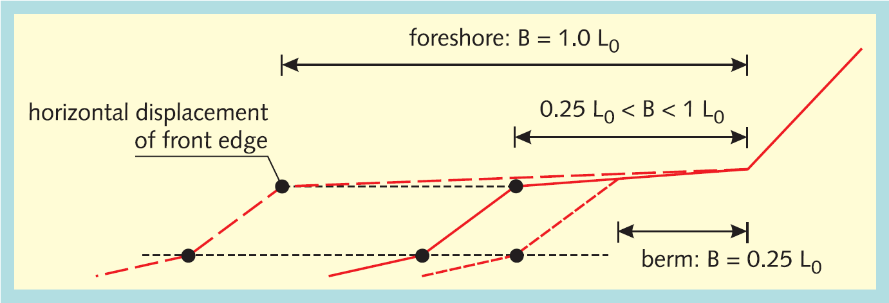

Figure 4.2 Procedure to split a cross section with a wide berm into two separate cross sections

**Input:**

Tm-1,0 (s) spectral wave period

x (m) x-coordinates cross section with at least wide berm

y (m+NAP) y-coordinates cross section with at least wide berm (y1,..., yN)

**Global constants:**

g (m/s2) acceleration due to gravity

**Output:**

xB (m) x-coordinates cross section with no berms with a berm width more than one-quarter of the wave length

yB (m+NAP) y-coordinates cross section with no berms with a berm width more than one-quarter of the wave length

xF (m) x-coordinates cross section with at least one foreshore

yF (m+NAP) y-coordinates cross section with at least one foreshore

L0 (m) Wave length

Nb (-) Number of wide berms

**Calculation:**

1. Calculate the wave length L0 [section 4.5.3]
2. Determine the number of wide berms (Nb)
3. Determine the cross section with the berm (xB, yB) through interpolation using x and y. Figure 4.2 gives the derivation method.
4. Determine the cross section with the foreshore (xF, yF) through interpolation using x and y. Figure 4.2 gives the derivation method.

### Force horizontal berms

The influence factor of berms is computed with cross sections with horizontal berms. So, in addition to the cross section with non-horizontal berms, a calculation cross section with just horizontal berms is derived from the original cross section. The derivation is shown in Figure 4.3 for one berm. Each berm is treated in this way. The computation of the wave run-up and wave overtopping discharge is performed in an iteration process (paragraph 5.2). In this process the calculation cross section with just horizontal berms is used, but it isn't necessary to compute it in each iteration step. So this computation is done only once. It is done before the iteration process.

**Input:**

x (m) x-coordinates cross section with non-horizontal berms

y (m+NAP) y-coordinates cross section with non-horizontal berms

**Output:**

x (m) x-coordinates cross section with horizontal berms

y (m+NAP) y-coordinates cross section with horizontal berms

**Calculation:**

1. Assess the middle of the berm:





1. Calculate the lower slope:



1. Calculate the upper slope:



1. Calculate the starting point of the horizontal berm:



or, alternatively:





1. Calculate the end point of the horizontal berm:





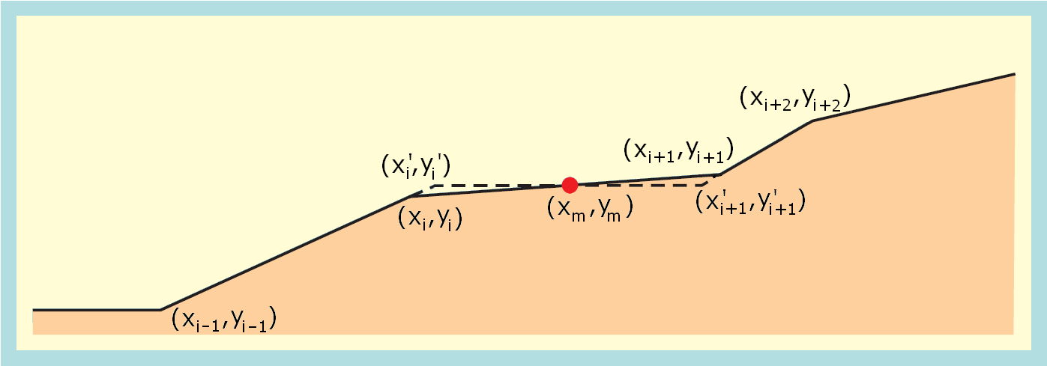

Figure 4.3 Adjustment of a non-horizontal berm

### Remove a horizontal berm

A horizontal berm is removed from a cross section by removing the inner end point of the berm and shifting all profile points higher than the berm horizontally outward, over a distance equal to the width of the horizontal berm.

## Calculate influence factors angle of wave attack

**Input:**

ψ (°N) orientation of the dike normal

ϕ (°N) Wave direction

Hm0 (m) Significant wave height

Tm-1,0 (s) Spectral wave period

**Output:**

β (°) Angle of wave attack

γβz (-) Influence factor angle of wave attack for 2% wave run-up

γβo (-) Influence factor angle of wave attack for overtopping

γs (-) Wave adjustment parameter

Hm0 (m) (Adjusted) Significant wave height

Tm-1,0 (s) (Adjusted) Spectral wave period

**Calculation:**

1. Calculate the angle of wave attack:



1. Calculate the influence factor for the angle of wave attack for 2% wave run-up ([TAW, 2002], formula 8, page 16):



1. Calculate the influence factor for the angle of wave attack for overtopping ([TAW, 2002], formula 9, page 16):



1. Calculate the wave adjustment parameter ([TAW, 2002], page 16):



1. Adjust the wave parameters ([TAW, 2002], page 16):





## Combine computation results for cross sections

If the original cross section – i.e. the cross section chosen by the user – includes at least one wide berm, then this cross section is split into two cross sections. For both cross sections a separate computation is made. The results of these two computations have to be combined ([TDR, 2005], section 7.8).

**Input:**

z2%,B (m) 2% wave run-up height of cross section without any wide berm, but with at least one berm

z2%,F (m) 2% wave run-up height of cross section without any wide berm, but with at least one foreshore

qo,B (m3/ms) wave overtopping discharge per meter crest width of cross section without any wide berm, but with at least one berm

qo,F (m3/ms) wave overtopping discharge per meter crest width of cross section without any wide berm, but with at least one foreshore

Nb (-) Number of wide berms

B (m) Array of berm widths of wide berms

L0 (m) wave length

**Output:**

z2% (m) 2% runup height

qo (m3/ms) overtopping discharge

**Calculation:**





## Calculate limit state function wave overtopping discharge

**Input:**

qo (m3/ms) wave overtopping discharge per meter crest width

qc (m3/ms) critical value for the wave overtopping discharge per meter crest width

mqc (-) model factor describing the uncertainty of qc

mqo (-) model factor describing the uncertainty of qo

**Output:**

Z (-) limit state for wave overtopping discharge

**Calculation:**



Where

qo,min (m3/ms) Minimum value for the computed wave overtopping discharge, introduced in order to avoid computing log(0). It is set equal to the smallest positive (non zero) number, within the accuracy settings of the kernel.

# Computation method

## Introduction

This chapter describes the computation method to calculate the wave run-up and wave overtopping discharge over the crest of a dike. First the calculation steps are presented (paragraph 5.2). In the next paragraph functions are described in detail.

## Calculation steps

1. If applicable, adjust non-horizontal berms to horizontal berms [section 4.6.4].
2. Iterate*) until 2% wave run-up reaches an equilibrium:
   1. Estimate 2% wave run-up: z2% (if available, use result of former iteration step, otherwise assume z2% = 1.5 Hm0 as initial value)
   2. Calculate representative slope angle tan α [section 5.3.1].
   3. Calculate z2%,smooth, neglecting the effect of berms and roughness (assume γb=1 and γf=1) [section 5.3.2].
   4. Calculate influence factor roughness on slope: γf [section 5.3.4].
   5. Calculate z2%,rough, neglecting the effect of berms (assume γb = 1) [section 5.3.2].
   6. Calculate influence factor berms: γb [section 5.3.5].
   7. Calculate new influence factor roughness on slope: γf [section 5.3.4].
   8. If applicable, adjust the influence factors [section 5.3.8]
   9. Calculate 2% wave run-up: z2% [section 5.3.2].
3. Calculate wave overtopping discharge: qo [section 5.3.9].

**Remarks**

*) Convergence of the iteration process cannot be guaranteed. The stopping criterion will become a function of two subsequent iteration steps.

## Detailed functions

### Calculate representative slope angle

**Input:**

SWL (m+NAP) Still water level

Hm0 (m) Significant wave height

z2% (m) 2% runup height

x (m) x-coordinates cross section without berms

y (m+NAP) y-coordinates cross section without berms

**Output:**

tanα (-) representative slope angle

**Calculation:**

The calculation of the representative slope is displayed in Figure 5.1 ([TAW, 2002], page 13). The representative slope angle is the average slope in the zone between SWL – 1.5 Hm0 and SWL + z2%. Berms must be disregarded in this calculation.

The first time the representative slope angle is calculated, the 2% wave run-up is unknown. As initial value for the wave run-up z2% = 1.5 Hm0 is used.

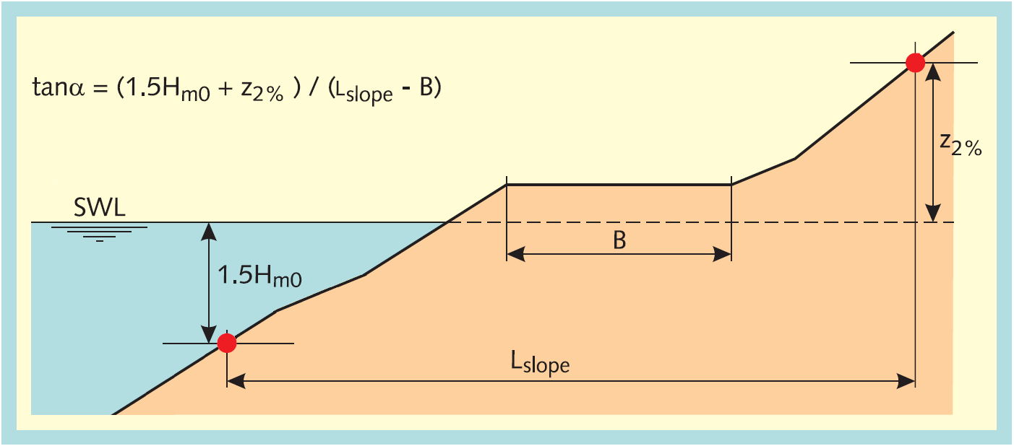

Figure 5.1 Calculation of the representative slope for a cross section with multiple sections

Because a cross section without berms is the input, the calculation of the representative slope angle uses the following steps:

1. Determine ylower:



1. Determine the corresponding xlower through interpolation using x and y
2. Determine yupper



1. Determine the corresponding xupper through interpolation using x and y
2. Calculate the representative slope angle:



### Calculate 2% wave run-up

**Input:**

Hm0 (m) Significant wave height

Tm-1,0 (s) Spectral wave period

tanα (-) representative slope angle

γβz (-) Influence factor angle of wave attack for wave run-up

γf (-) Influence factor roughness

γb (-) Influence factor berms

frun-up1 (-) Model factor wave run-up 1 (1.75 in [TAW, 2002], formula 3a)

frun-up2 (-) Model factor wave run-up 2 (4.3 in [TAW, 2002], formula 3b)

frun-up3 (-) Model factor wave run-up 3 (1.6 in [TAW, 2002], formula 3b)

**Output:**

ξo (-) Breaker parameter

so (-) Wave steepness

 (-) intersection point for breaking and non-breaking waves

z2% (m) 2% run-up height

**Calculation:**

1. Calculate the wave steepness [section 4.5.3]
2. Calculate the breaker parameter ([TAW, 2002], formula 1, page 8):



1. Calculate the intersection point for breaking and non-breaking waves [section 5.3.3].
2. For small breaker parameter calculate the 2% wave run-up for breaking waves ([TAW, 2002], formula 3a, page 8), otherwise calculate 2% wave run-up for non-breaking waves ([TAW, 2002], formula 3b, page 9):



### Calculate intersection point breaking and non-breaking waves

**Input:**

γb (-) Influence factor berms

frun-up1 (-) Model factor wave run-up 1 (1.75 in [TAW, 2002], formula 3a)

frun-up2 (-) Model factor wave run-up 2 (4.3 in [TAW, 2002], formula 3b)

frun-up3 (-) Model factor wave run-up 3 (1.6 in [TAW, 2002], formula 3b)

**Output:**

 (-) Intersection point for breaking and non-breaking waves

**Calculation:**

1. Solve ξ0 in the equation



using cubic roots solver.

1. Choose in solutions for ξ0 the relevant intersection point (Figure 5.2).
2. If no solution is found, set ξ0 = 0.
3. Assess :





Figure 5.2 Wave run-up as function of breaker parameter

### Calculate influence factor roughness on slope

**Input:**

x (m) x-coordinates cross section (x1,..., xN)

y (m+NAP) y-coordinates cross section (y1,..., yN)

r (-) roughness factor dike segments (r1,..., rN-1)

SWL (m+NAP) Still water level (i.e. local water level)

z2%,smooth (m) 2% runup height without roughness

 (-) intersection point for breaking and non-breaking waves

γb (-) Influence factor berms

ξo (-) Breaker parameter

**Output:**

γ­f (-) Influence factor roughness

**Calculation:**

1. Determine ylower:



1. Determine yupper



1. Determine the roughness (r,i) and the length (Li) of the segments between ylower and yupper
2. Calculate the influence factor for the roughness ([TAW, 2002], formula 19, page 25):



1. Adjust the influence factor for large breaker parameter values ([TAW, 2002], page 20):



### Calculate influence factor berms

The permitted cross sections have a maximum of two berms (section 4.3). The computation of the influence of the berms is made with the calculation cross section with only horizontal berms with a maximal width of one-quarter of the wave length. The computation is made for each berm separately and afterwards the influences of the berms are combined.

**Input:**

x (m) x-coordinates cross section with horizontal berms and berm width is maximal one-quarter of the wave length

y (m+NAP) y-coordinates cross section with horizontal berms and berm width is maximal one-quarter of the wave length

**Output:**

γb (-) Influence factor berms

**Calculation:**

1. Calculate influence factor first berm [section 5.3.6]
   * if influence factor first berm equals 0.6 no further computations are needed:   
     total influence factor berms is equal to 0.6.
   * if a second berm exists:   
     calculate influence factor second berm [section 5.3.6]
   * if influence factor second berm equals 0.6 no further computations are needed:   
     total influence factor berms is equal to 0.6.
   * if applicable combine influence factors berms [section 5.3.7]
2. Calculate adjustment of influence factors [section 5.3.8]

### Calculate influence factor one berm

A berm in a cross section affects the wave run-up and the wave overtopping. The width of a berm is significant and also the position of the berm in relation to the still water line (SWL). The total influence of one berm is the combination of the influences of these two elements.

**Input:**

SWL (m+NAP) Still water level (i.e. local water level)

Hm0 (m) Significant wave height

z2%,rough (m) 2% runup height with roughness

x (m) x-coordinates cross section with horizontal berms and berm width is maximal one-quarter of the wave length

y (m+NAP) y-coordinates cross section with horizontal berms and berm width is maximal one-quarter of the wave length

**Output:**

γb (-) Influence factor berm

B (m) Berm width

Lberm (m) Length of the cross section with influence of the berm

rdh (m) depth of the berm in relation to the water level

**Calculation:**

In wave run-up formulas, the influence of a berm is calculated with a berm factor, in which two influences are taken into account:

* the influence of the width of the berm in relation to the wave height and the shape of the cross section (parameter rb)
* depth of the berm in relation to the water level (parameter rdh).

1. Determine Lberm – the length of the cross section against which the length of the berm is deposed – through interpolation using x and y. Figure 5.3 shows the derivation method. Note that the still water line (SWL) isn't relevant for Lberm. Restrict Lberm by using the toe and crest of the cross section in the computation of Lberm:





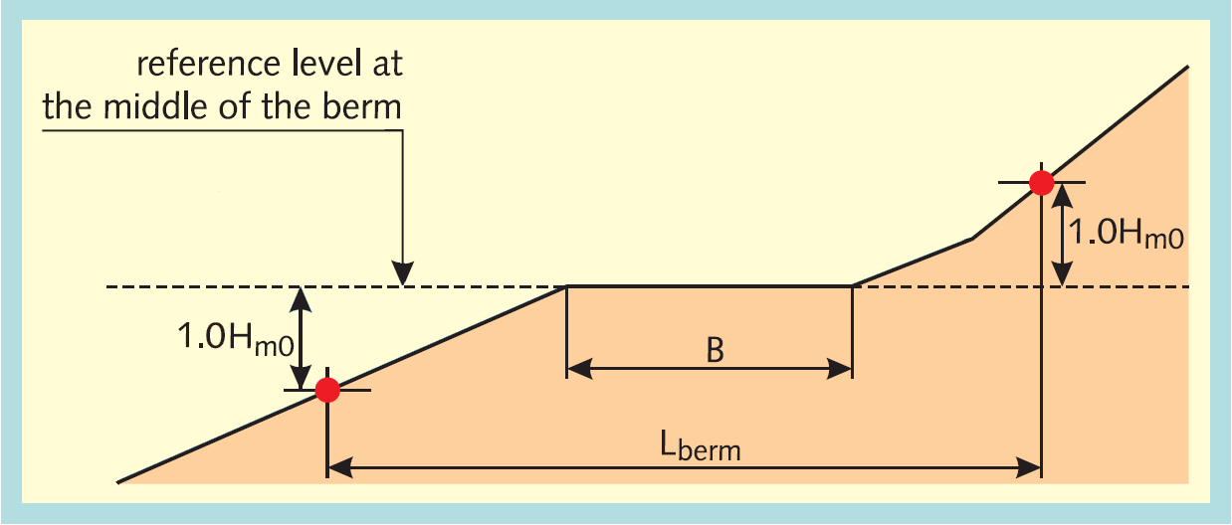

Figure 5.3 Computation of Lberm the length of the cross section against which the length of the berm is deposed

1. Calculate the influence of the width of the berm in relation to Lberm:



1. Calculate the difference between the berm height and the still water line:



1. Calculate the influence of the depth of the berm in relation to the still water line:



1. calculate;



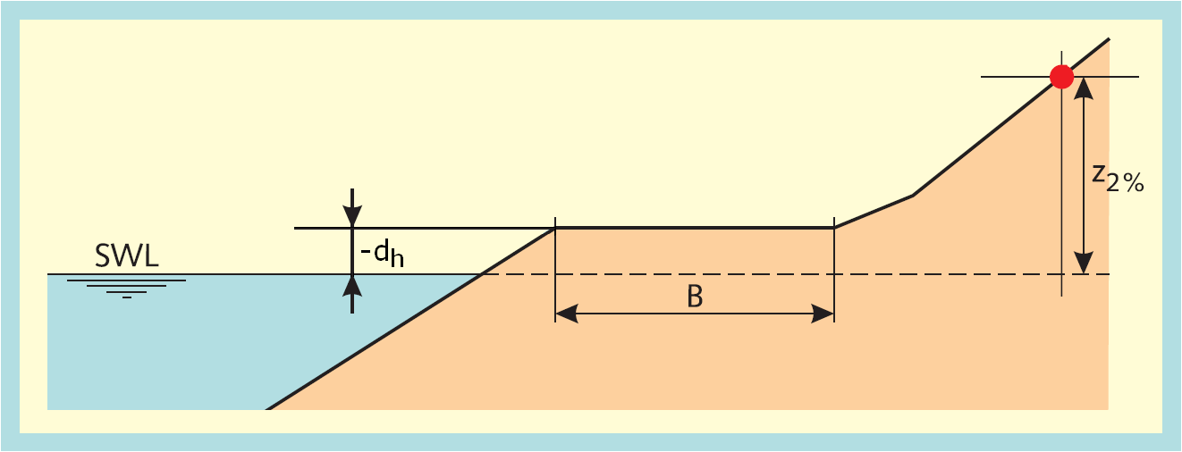

Figure 5.4 If the position of the berm is above the water level the parameter rdh is less than 1 (rdh < 1) as the difference of the berm height and the still water line is less than z2% (z2% > -dh)

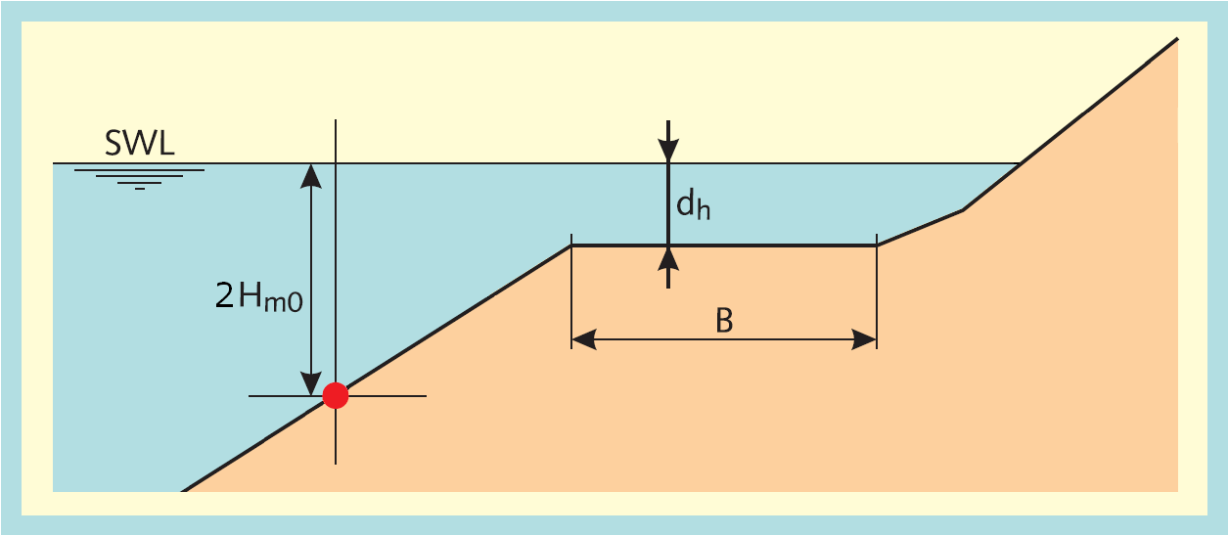

Figure 5.5 If the position of the berm is below the water level the parameter rdh is less than 1 (rdh < 1) as the difference of the berm height and the still water line is less than 2Hm0 (2Hm0 > dh)

### Combine influence factors berms

**Input:**

B (m) Berm widths (vector)

L (m) Length of the cross section with influence of the berm (vector)

rdh (m) depth of the berm in relation to the water level (vector)

**Output:**

γb (-) Influence factor berms

**Calculation:**

1. calculate for all berms i:



1. calculate for all berms i: f2(i)



1. calculate f3



1. calculate f4



1. calculate f5



1. calculate γb



N.B. The above formulas give in case of only one berm exactly the formula used for one berm.

### Calculate adjustment of influence factors

**Input:**

γb (-) Influence factor berms

γβ (-) Influence factor angle of wave attack (for 2% wave run-up or overtopping)

γ­f (-) Influence factor roughness

ξo (-) Breaker parameter

 (-) intersection point for breaking and non-breaking waves

**Output:**

γb (-) Influence factor berms

γβ (-) Influence factor angle of wave attack (for 2% wave run-up or overtopping)

γ­f (-) Influence factor roughness

**Calculation:**

A requirement of the influence factors (γb, γf, γβ) is that the product of these influence factors is not less than 0.4. In case it is less the minimum factor of 0.4 should be used for the product of the influence factors ([TAW, 2002], formula 6, page 12). For some calculation steps in the computations of the wave run-up (paragraph 5.3.2) and in the computations of the wave overtopping (paragraph 5.3.9) the total influence factor is used and for other steps the individual influence factors are used. In order to use consistent influence factors, all the influence factors are adapted if the total influence factor is less than 0.4. The adjustment ensures that the product of the influence factors is equal to 0.4. The adjustment of the influence is only calculated if the product of the influence factors is less than 0.4.

1. Calculate the total influence factor



1. Calculate the ratio for the influence factor of roughness in relation to the minimum influence factor of roughness,



where γf,min = 0.55 ([TDR, 2005], page 26 and 28).

1. Calculate the ratio for the influence factor of berms in relation to the minimum for influence factor of berms



where γb,min = 0.6 ([TDR, 2005], page 26 and 28).

1. Calculate the ratio for the influence factor of wave attack in relation to. the minimum for influence factor of wave attack:



where γβ,min = 0.824 for 2% wave run-up ([TDR, 2005], page 26) and γβ,min =0.736 for wave overtopping ([TDR, 2005], page 28).

1. Calculate the sum of the ratios:



1. Adapt the influence factors:







### Calculate wave overtopping discharge

**Input:**

y (m+NAP) y-coordinates cross section (y1,..., yN)

h (m+NAP) Still water level (i.e. local water level)

Hm0 (m) Significant wave height

tanα (-) representative slope angle

γβo (-) Influence factor angle of wave attack for overtopping

γb (-) Influence factor berms

γ­f (-) Influence factor roughness

fb (-) Model factor for breaking waves (4.3 in [TAW, 2002], formula 22)

fn (-) Model factor for non-breaking waves (2.3 in [TAW, 2002], formula 23)

fshallow (-) Model factor for shallow waves (0.21 in [TAW, 2002], formula 26)

ξo (-) Breaker parameter

g (m/s2) acceleration due to gravity

**Output:**

qo (m3/ms) overtopping discharge

**Calculation:**

1. Calculate adjustment of influence factors [section 5.3.8]
2. If the breaker parameter ξ0 ≤ 5, calculate the dimensionless overtopping discharge for breaking waves ([TAW, 2002], formula 22, page 26):



1. If the breaker parameter ξ0 < 7, calculate the dimensionless overtopping discharge for non-breaking waves ([TAW, 2002], formula 23, page 26):



1. If the breaker parameter ξ0 > 5, calculate the dimensionless overtopping discharge for shallow water ([TAW, 2002], formula 26, page 31):



with:



1. Calculate the overtopping discharge:

* ([TAW, 2002], formulae 22 & 23, page 26):



* ([TAW, 2002], page 31):



* ([TAW, 2002], formula 26, page 31):



# Foreshore

A cross section contains a foreshore if the length of a berm segment (the gradient of the segment has a maximum of 1:15) is at least one wave length (L0). If the cross section contains a foreshore there are three possibilities for the still water line (SWL):

1. The still water line is below the foreshore (Figure 6.1):
   * Adjust non-horizontal foreshores to horizontal foreshores (like a berm) [section 4.6.4]
   * The wave overtopping discharge is set equal to 0.
   * For the computation of the 2% wave run-up (z2%) use the calculation steps in [section 5.2]. The difference between the water level h and the height of the horizontal foreshore is the maximum of the 2% wave run-up.
2. The still water line is on the foreshore (Figure 6.2):
   * The 2% wave run-up (z2%) is equal to 0.
   * The wave overtopping discharge is equal to 0.
3. The still water line is above the foreshore (Figure 6.3):
   * The cross section is adjusted by removing the foreshore and all segments below the foreshore. The end of the foreshore in the original profile becomes the toe of the new profile.
   * The wave conditions are adjusted on the basis of the new toe level (Figure 6.3), [section 4.5.2].
   * No adjustments are made to the wave period Tm-1,0 and the wave direction ϕ.
   * Start computation method in section 5.2 after the above adjustments.

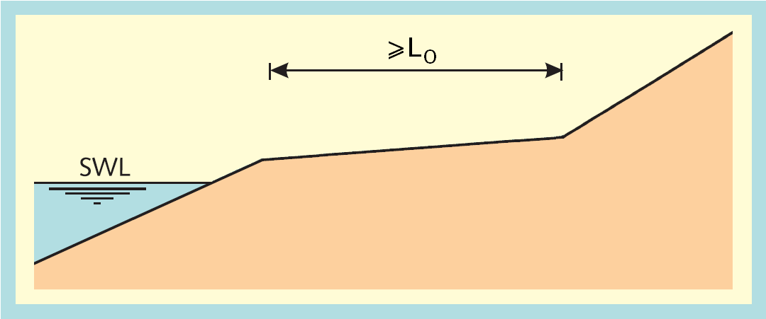

Figure 6.1 Still water line (SWL) below the foreshore

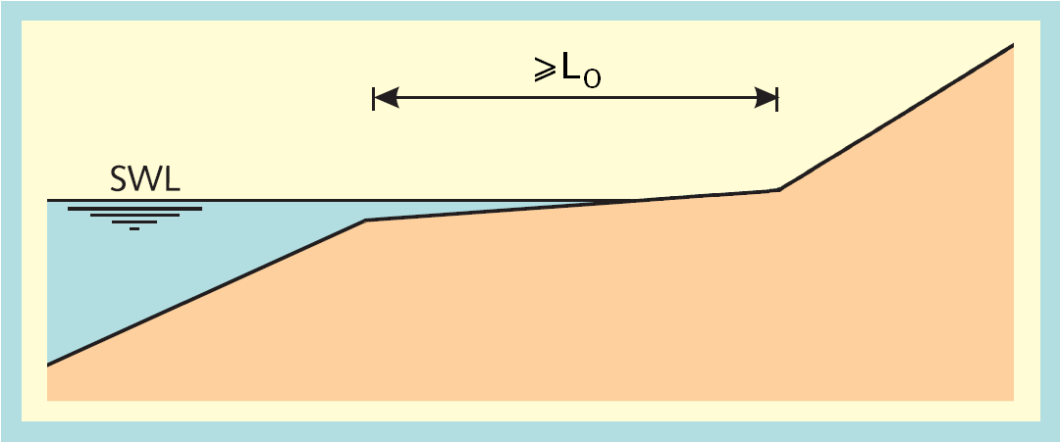

Figure 6.2 Still water line (SWL) on the foreshore

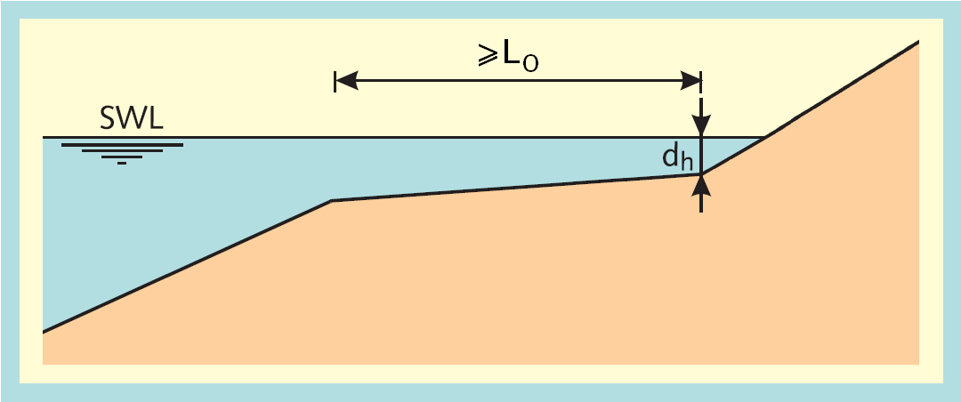

Figure 6.3 Still water line (SWL) above the foreshore

# Notes

**Kernel output**

The kernel does not facilitate the calculation of a 'hydraulic load level'. However, it is estimated to be relatively easy to add such a (useful!) procedure to the dll functionalities in the future.

**Taking foreshores into account**

The computation method to account for foreshores (Chapter 6) is likely to yield discontinuities for a gradually increasing water level and a sloping foreshore. For water levels below the foreshore, the foreshore should not be adjusted to horizontal and the 2% run-up should be limited to the height of the outer point of the foreshore with respect to the water level.

# References

[Duits en Kuijper, 2012]

Hydra-Zoet – Gebruikershandleiding – Versie 1.6 [HKV-rapport PR1564]. M.T. Duits en B. Kuijper. HKV LIJN IN WATER. Lelystad, juli 2012.

[TAW, 2002]

Technisch Rapport Golfoploop en Golfoverslag bij Dijken. J.W. van der Meer. Technische Adviescommissie voor de Waterkeringen (TAW). Delft, mei 2002.

[TDR, 2005]

Technisch definitierapport PC-Overslag, bijgewerkt tot en met juni 2005.

1. This value is based on the fact that 10C in [TAW, 2002] formula 27 is equal to 0.21 in design applications [TAW, 2002] formula 26.
2. Instead, the module does verify the far more relaxed requirement of a minimum distance of 2 cm, which seems appropriate for a robust computation of the segment gradient.